1-Generate your private/public keys using openssl

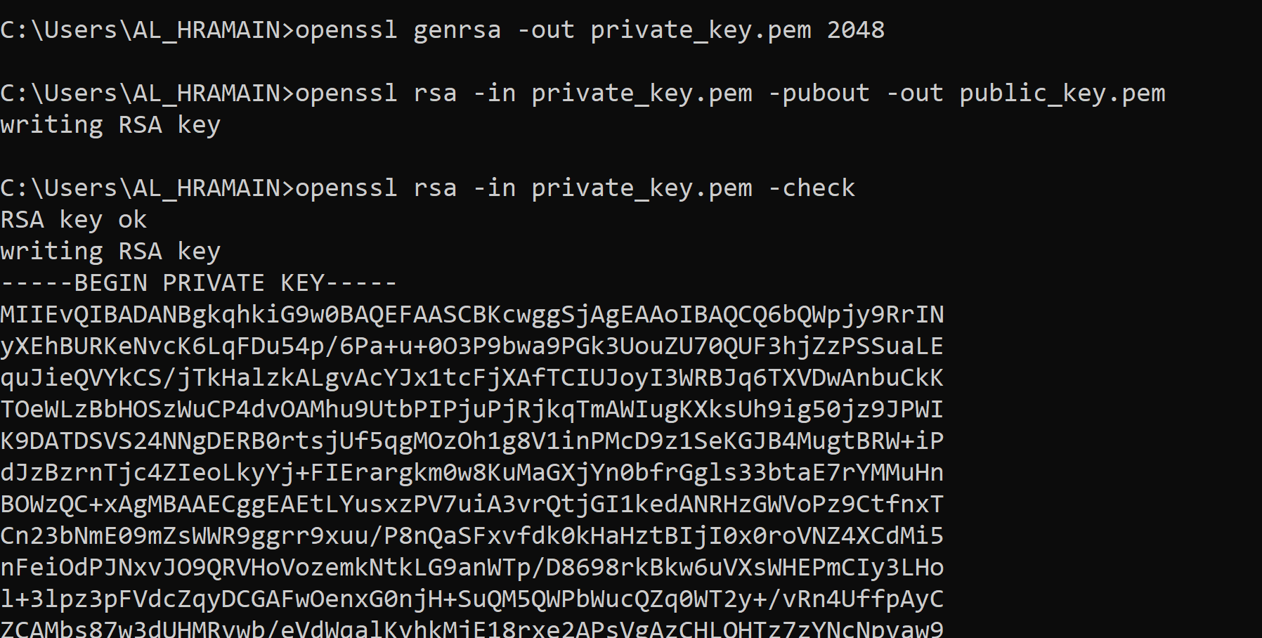

2-Send your public key to your friend



3-Write a text file, encrypt it and send to your friend

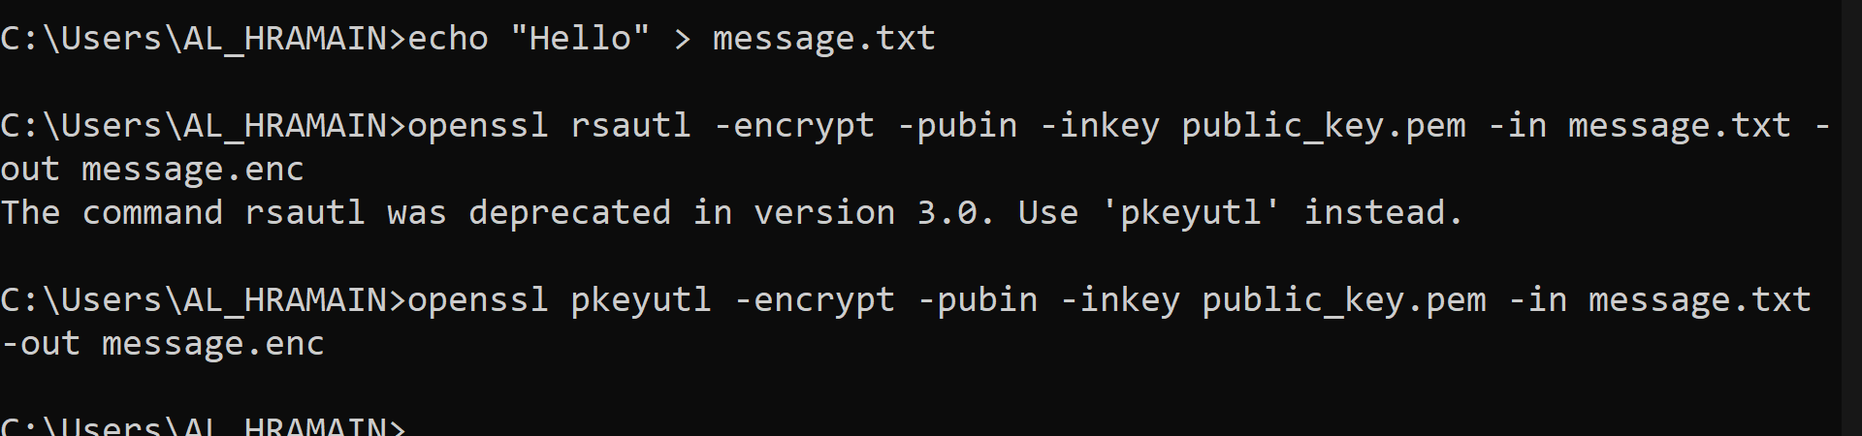

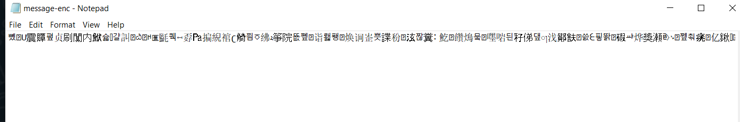

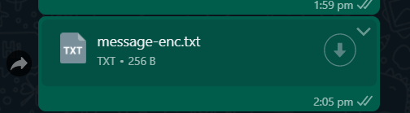

4-Your friend decrypt the file, and read its content





5-Generate a self signed certificate to use with http to run https

